SIMATS ENGINEERING
ASSESSMENT TOOL 1: Analytical Problem Solving

COURSE NAME: | Cloud Computing and Big Data Analytics | COURSE CODE: | CSA1516

COURSE OUTCOME COVERED
CO2: Analyze virtualization architectures to identify performance and security issues in cloud computing environments. (BL3)
Assessment Tool Weightage: 40%

Dave's Taxonomy: Manipulation (Level 2)  Question Count: 5 | Total Marks: 50

Code of Conduct
I _POOJA.S(192524326)__ (Name / Reg No) certify that this submission is my original work and that I have adhered to the guidelines specified for this assessment.
I understand that any violation of academic integrity rules will result in disciplinary action.
Signature of the student:

Assessment Tasks
Analytical Problem Solving
- Compare Type-1 and Type-2 hypervisors for a cloud datacenter hosting mission-critical applications. Analyze performance, security, and manageability, then justify the better choice.
- A cloud provider must isolate workloads belonging to finance, healthcare, and student portals on the same hardware. Analyze how virtualization architecture supports isolation and identify two major attack surfaces.
- Study the following VM host utilization snapshot and recommend corrective actions: CPU 92%, memory 88%, storage I/O latency 35 ms, average VM boot time 170 s. Explain the likely bottlenecks.
- Analyze how Software Defined Datacenter architecture improves agility compared with a traditional datacenter. Support your answer with compute, storage, and network virtualization considerations.
- A multi-cloud federation project fails due to identity mismatches between providers. Analyze the issue and propose a secure identity and privacy design using federation concepts.

Analytical Problem Solving Rubric

Criteria | Weightage | Level 4 - Exemplary | Level 3 – Proficient | Level 2 - Developing | Level 1 - Beginning
Problem Interpretation | 20% | Interprets all technical requirements accurately | Interprets most requirements correctly | Partial interpretation | Misinterprets the problem
Analytical Reasoning | 25% | Strong reasoning with clear cause-effect analysis | Good reasoning with minor gaps | Basic analysis only | Weak or no analysis
Method Selection | 20% | Chooses highly appropriate virtualization and security concepts | Chooses mostly suitable concepts | Partially suitable concepts | Inappropriate approach
Solution Quality | 20% | Provides feasible and technically sound solution | Reasonable solution with minor issues | Basic solution with limitations | Unclear or invalid solution
Presentation of Analysis | 15% | Well-structured and technically precise | Generally clear | Somewhat unclear | Difficult to follow

Total Marks Awarded:

Solutions:
Question 1
1.1 Introduction
A hypervisor is software or firmware that creates and manages virtual machines (VMs) by sharing the physical resources of a computer. It allows multiple operating systems to run on the same physical server.
There are two types of hypervisors: Type-1 and Type-2.

1.2 Comparison between Type-1 and Type-2 hypervisors
Feature | Type-1 Hypervisor | Type-2 Hypervisor
Also called | Bare-metal hypervisor | Hosted hypervisor
Installation | Runs directly on hardware | Runs on a host operating system
Performance | High performance | Comparatively lower performance
Security | Smaller host OS attack surface | Depends on host OS security
Resource management | Directly manages hardware resources | Accesses resources through host OS
Scalability | Suitable for large datacenters | Suitable for desktops and testing
Manageability | Centralized management tools | Usually managed on individual systems
Examples | VMware ESXi, Microsoft Hyper-V, Xen | Oracle VirtualBox, VMware Workstation

1.3 Performance analysis
- Type-1: Direct access to hardware reduces overhead and provides better CPU, memory, and I/O performance.
- Type-2: Requires an additional host operating system layer, which may introduce extra overhead and latency.
For mission-critical applications, Type-1 provides more predictable performance.

1.4 Security analysis
- Type-1 has a smaller software layer between the hardware and VMs, reducing some potential attack surfaces.
- Type-2 depends on the security of both the hypervisor and host operating system.
- Both require security patches, access control, network isolation, and monitoring.

1.5 Manageability analysis
Type-1 hypervisors support centralized administration, VM migration, resource allocation, monitoring, and high-availability configurations. These features help administrators manage many servers efficiently.
Type-2 hypervisors are easier to install for individual testing but are less suitable for large production datacenters.

1.6 Justification
Type-1 hypervisor is the better choice for mission-critical cloud applications because it provides:
- Higher performance and lower overhead.
- Better control over physical resources.
- Stronger isolation architecture when properly configured.
- Centralized management and scalability.
- Support for high availability and live migration in suitable platforms.

Conclusion
Type-1 hypervisors are recommended for production cloud datacenters because of their performance, security architecture, and manageability. Type-2 hypervisors are more suitable for development, testing, and personal use.

Question 2
2.1 Introduction
Virtualization enables multiple virtual machines to run on a single physical server. A cloud provider can host finance, healthcare, and student applications on shared hardware while separating their resources and access.

2.2 Virtualization architecture
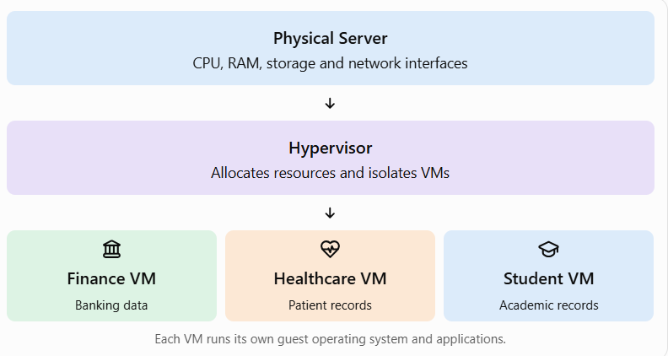

2.3 How virtualization provides isolation
a) Compute isolation: Each VM receives allocated CPU and memory resources. One VM should not directly access another VM's memory.
b) Storage isolation: Separate virtual disks, permissions, and encryption prevent unauthorized access to other tenants' files.
c) Network isolation: Virtual networks, VLANs, virtual firewalls, and security groups restrict communication between finance, healthcare, and student workloads.
d) Access control: Role-based access control (RBAC) ensures that administrators and users can access only authorized resources.
e) Resource control: CPU and memory limits reduce the risk of one tenant exhausting resources needed by other tenants.

2.4 Two major attack surfaces
Attack surface 1: Hypervisor vulnerabilities
An attacker may exploit a hypervisor vulnerability to escape from a VM and access the host or other VMs. This is known as a VM escape.
Prevention:
- Regularly patch and update the hypervisor.
- Restrict administrative access.
- Disable unnecessary services.
- Monitor hypervisor logs and suspicious activity.
Attack surface 2: Virtual network and management interfaces
Misconfigured virtual switches, exposed management interfaces, or weak administrator credentials may allow unauthorized access or communication between tenants.
Prevention:
- Apply network segmentation and firewall rules.
- Use multifactor authentication (MFA).
- Encrypt management traffic.
- Apply least-privilege access control.

2.5 Additional security measures
- Encrypt sensitive data at rest and in transit.
- Maintain audit logs.
- Back up critical data securely.
- Regularly test isolation and security configurations.

Conclusion
Virtualization enables multiple organizations to share physical hardware while maintaining separate computing environments. A secure hypervisor, proper network segmentation, access control, and continuous monitoring are essential to protect finance, healthcare, and student data.

Question 3
3.1 Introduction
Virtual machine host utilization measures how efficiently the physical server's resources are being used. High CPU, memory, and storage utilization can reduce VM performance and increase boot time.

3.2 Analysis of the utilization snapshot
Metric | Given value | Analysis
CPU utilization | 92% | Very high; little processing capacity remains
Memory utilization | 88% | High; may lead to memory pressure
Storage I/O latency | 35 ms | Potential storage bottleneck, especially for latency-sensitive workloads
Average VM boot time | 170 seconds | Slow; may indicate resource contention or initialization delays

3.3 Likely bottlenecks
a) CPU bottleneck
CPU utilization of 92% indicates that the host is heavily loaded. When many VMs compete for processor time, scheduling delays can occur.
Effects:
- Slow application response.
- Delayed VM startup.
- Increased processing time.
b) Memory bottleneck
Memory utilization of 88% leaves limited free RAM. If the host cannot satisfy memory demands, it may use memory reclamation, ballooning, or swapping.
Effects:
- Increased memory access delays.
- Slower applications.
- Reduced performance during peak usage.

c) Storage I/O bottleneck
Storage latency of 35 ms may be high for many production workloads, depending on the storage type and application requirements. It may result from excessive simultaneous disk operations, slow disks, or an overloaded storage array.
Effects:
- Slow disk reads and writes.
- Delayed operating system startup.
- Slow database operations.
d) VM boot-time bottleneck
An average boot time of 170 seconds indicates that startup performance needs investigation. Possible causes include CPU contention, memory pressure, storage latency, and operating system initialization tasks.

3.4 Recommended corrective actions
Problem | Corrective action
CPU at 92% | Balance workloads, reduce unnecessary CPU allocation, and migrate VMs to less-loaded hosts
Memory at 88% | Add RAM, right-size VM memory, and investigate swapping or ballooning
Storage latency at 35 ms | Use faster storage, optimize disk I/O, and check storage queue depth
Boot time at 170 s | Identify slow startup services, reduce unnecessary startup tasks, and improve storage performance

3.5 Implementation strategy
- Monitor CPU, memory, and disk metrics over time.
- Identify VMs that consume excessive resources.
- Use load balancing or live migration where supported.
- Upgrade host memory or CPU capacity if the load is sustained.
- Improve storage performance using SSDs or suitable high-performance storage.

- Measure boot time and host utilization again after applying the changes.

3.6 Expected outcome
The corrective actions should reduce resource contention, improve VM responsiveness, and shorten startup time. Actual improvement must be verified through post-change monitoring.
Conclusion
The main bottlenecks are high CPU utilization, high memory utilization, and potentially excessive storage latency. Resource optimization, workload balancing, and storage improvements are recommended before deciding whether additional hardware is required.

Question 4
4.1 Introduction
A Software Defined Datacenter (SDDC) is a datacenter in which computing, storage, and networking resources are virtualized and managed through software. Automation and centralized control reduce the need for manual hardware configuration.

4.2 Traditional datacenter vs SDDC
Feature | Traditional Datacenter | SDDC
Resource management | Mostly manual | Software-based and automated
Compute | Physical servers are provisioned individually | Virtual machines and virtual compute resources
Storage | Physical storage systems | Software-defined storage pools
Networking | Hardware-based configuration | Software-defined networks and virtual switches
Scalability | Often requires manual setup | Resources can be provisioned rapidly
Flexibility | Comparatively limited | More flexible and programmable
Management | Separate tools for different resources | Centralized management and orchestration

4.3 SDDC architecture
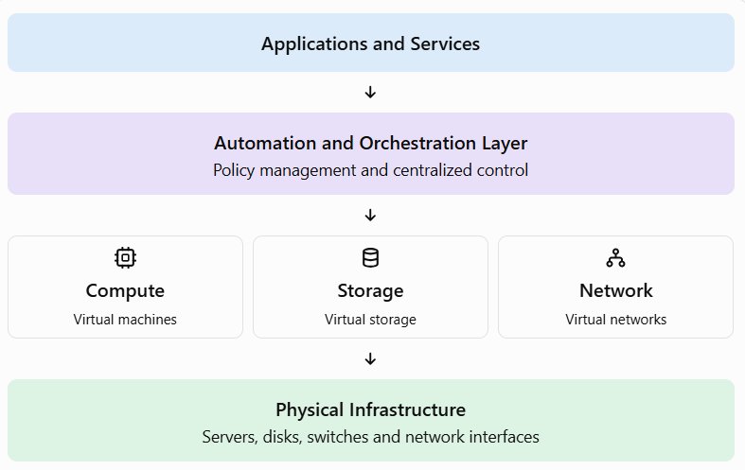

4.4 Role of virtualization
a) Compute virtualization
A hypervisor creates multiple VMs on physical servers. Administrators can provision, resize, migrate, and manage VMs through software.
Benefit: Faster deployment and improved resource utilization.
b) Storage virtualization
Multiple physical storage devices can be combined into logical storage pools. Software manages capacity allocation, replication, and data placement.
Benefit: Easier storage provisioning, flexible capacity expansion, and simplified management.
c) Network virtualization
Virtual switches, software-defined networking (SDN), and virtual firewalls allow networks to be created and configured through software.
Benefit: Faster network setup, improved isolation, and easier policy enforcement.

4.5 How SDDC improves agility
- Rapid provisioning: New computing resources can be deployed quickly.
- Automation: Repetitive administrative tasks can be automated.
- Scalability: Resources can be increased or decreased according to demand.
- Resource efficiency: Workloads can share infrastructure more effectively.
- Centralized management: Administrators can manage resources through common control systems.
- Improved disaster recovery: Replication, backup, and recovery processes can be automated.
- Policy-based security: Security and access policies can be applied consistently.

4.6 Example
Suppose a university needs additional servers, storage, and network capacity during student admissions. In a traditional datacenter, administrators may need to configure several physical systems manually. With SDDC, they can provision additional VMs, allocate storage, and configure isolated virtual networks using software management tools.
Conclusion
SDDC improves datacenter agility through compute, storage, and network virtualization, along with automation and centralized management. It enables faster provisioning, easier scaling, and more efficient resource utilization than a predominantly manual traditional datacenter.

Question 5
5.1 Introduction
Multi-cloud federation allows an organization to use services from multiple cloud providers while coordinating identity, access, and resource management.
Identity mismatches occur when different providers use incompatible user identifiers, authentication methods, roles, or access policies.

5.2 Analysis of the problem
Consider an organization using Cloud Provider A for student records and Cloud Provider B for analytics.
Provider A identifies a user through an email address, while Provider B expects a different username or identity format. If their identity and authorization systems are not mapped correctly, users may be denied access or receive excessive permissions.
Major causes:
- Different user identifiers and identity formats.
- Incompatible authentication protocols.
- Different role names and permission models.
- Missing trust relationships between providers.
- Incorrect certificate or token validation.
- Inconsistent session and token expiration policies.

5.3 Proposed secure identity federation architecture
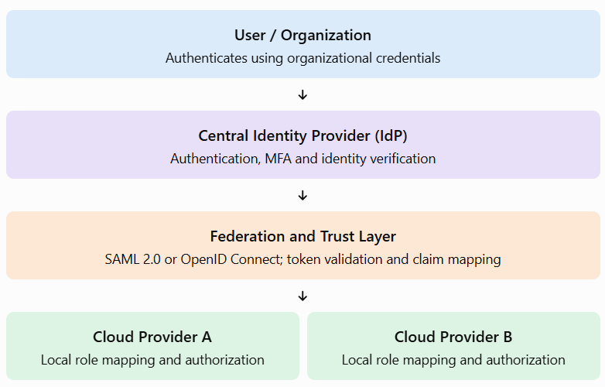

5.4 Secure identity design
a) Centralized identity provider
Use a trusted organizational identity provider to authenticate users. Each cloud provider establishes a trust relationship with the identity provider.

b) Standard federation protocols
- SAML 2.0: Exchanges authentication assertions between identity and service providers.
- OpenID Connect (OIDC): Provides authentication using an identity layer built on OAuth 2.0.
- OAuth 2.0: Supports delegated authorization to access protected resources.
The selected protocols must be supported by the participating providers.
c) Identity mapping
Create a common identity mapping strategy using stable identifiers and standardized claims. Map external identities to provider-specific roles rather than assuming that identical usernames represent the same person.
d) Role-based access control
Use RBAC and least-privilege principles. For example, a healthcare employee should not automatically gain access to finance data merely because both accounts belong to the same organization.
e) Strong authentication
Implement multifactor authentication, short-lived access tokens, secure key management, and appropriate token validation.

5.5 Privacy and data protection
- Data minimization: Share only the identity attributes required by each cloud service.
- Encryption: Protect identity assertions, tokens, and sensitive information in transit.
- Pseudonymous identifiers: Avoid sharing personal identifiers when they are not necessary.
- Consent and purpose limitation: Use personal information only for authorized purposes.
- Audit logging: Record authentication and access events without unnecessarily exposing sensitive data.
- Token security: Validate token signatures, issuer, audience, expiration, and other required claims.
- Revocation: Ensure that access can be withdrawn when users leave the organization or their permissions change.

5.6 Implementation steps
- Inventory identities, roles, and authentication systems across providers.
- Select a trusted identity provider and supported federation protocol.
- Configure trust relationships and map identity claims.
- Define consistent access policies and provider-specific roles.
- Enable MFA, encryption, logging, and token validation.
- Test successful login, denied access, expired tokens, and account revocation.
- Monitor federation logs and review permissions regularly.

5.7 Expected outcome
The proposed design should reduce identity mismatches, enable secure access across clouds, prevent unauthorized privilege escalation, and minimize unnecessary sharing of personal information.
Conclusion
A multi-cloud federation project requires interoperable identity standards, correct identity mapping, trusted authentication, and consistent authorization policies. A centralized identity provider combined with SAML or OIDC, least-privilege access, and privacy controls provides a secure approach to multi-cloud identity management.

